Discussion Held on 3 October, 2026

Discussion Summary
Project: Ati Priye Soch Foundation — Website Redesign & Development
Discussion Date: 3 October 2026

1. Project Overview
A discussion was held with Ati Priya Sir regarding the redesign and development of a complete website for the Ati Priye Soch Foundation.
The current website was found to be monotonous and does not properly represent the foundation's vision, activities, and objectives. The goal is to create a professional, engaging, informative, and scalable website that communicates the foundation's work effectively.

2. Reference Websites
Ati Priya Sir shared the following websites as design and content references:
- Khalsa Aid — https://khalsaaid.org/
- Smile Foundation — https://www.smilefoundationindia.org/
- Initiators of Change — https://initiatorsofchange.com/
These will be used for inspiration regarding website structure, visual presentation, and communication style.

3. Information & Documents Shared
Ati Priya Sir has provided the following documents for understanding the foundation:
- Memorandum of Association (MOA)
- Articles of Association (AOA)
- First Activity Report
- Foundation Bible
These documents will help in understanding the foundation's objectives, structure, and activities and will be used as references while preparing the website content.

4. Key Requirements
- Complete redesign of the existing website.
- Clear presentation of the foundation's mission, vision, objectives, pillars, and activities.
- Modern and professional UI/UX that better represents the foundation.
- Editable website content so that authorized users can update information without depending on a developer.
- Proper presentation of programmes, activities, achievements, and future initiatives.
- Website structure that can support future growth and expansion.

5. Long-Term Vision
Ati Priya Sir discussed the foundation's future expansion, including:
- Increasing the number of volunteers.
- Creating different chapters of the foundation.
- Providing identification/IDs to volunteers associated with different chapters.
- Expanding programmes through different mediums and locations.
- Developing an international-level presence.
- Pursuing opportunities for recognition or listing with organizations such as the United Nations and WHO.
The website should therefore be designed with future scalability in mind rather than only focusing on the current requirements.

6. Next Steps
- Study the MOA, AOA, and Activity Report.
- Audit the existing website and identify design, content, and technical issues.
- Analyze the provided reference websites.
- Finalize the sitemap and website content requirements.
- Define the required features and future scalability requirements.
- Prepare the initial UI/UX design.
- Finalize the technical approach and development plan.

Issues Reported And Requirements Listed By Sir:
- Banner Images of Various Pages were to be changed like who we are page, etc.
- Forms On Pages are not properly layed - out.
- Forms were not working.
- On Page/Off Page SEO.
- Website Design based on 5 themes(women empowerment, etc.) provided by sir needed to be redesigned apart from the theme.
- Sir wants to integrate the razorpay payment gateway for donations.

I have found out how to change the banner image of the pages..
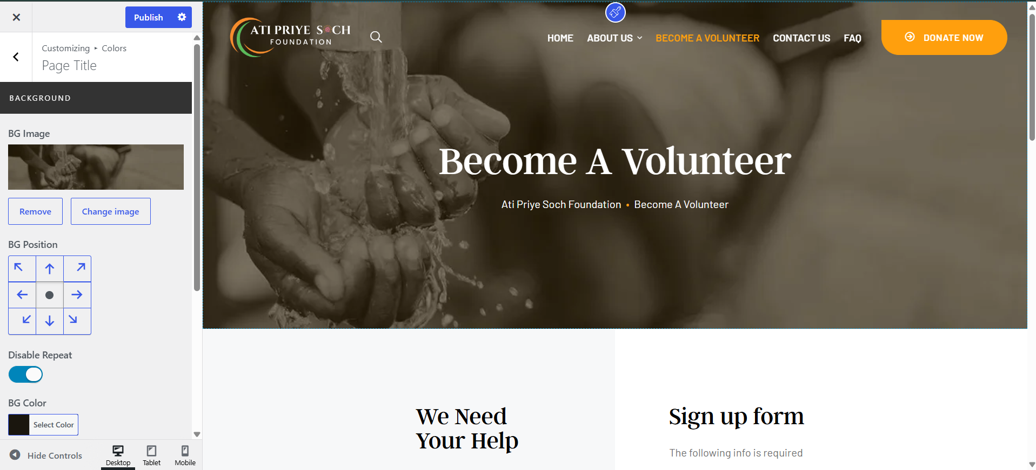

Second Site need to be fully update as it is running on older version of php.
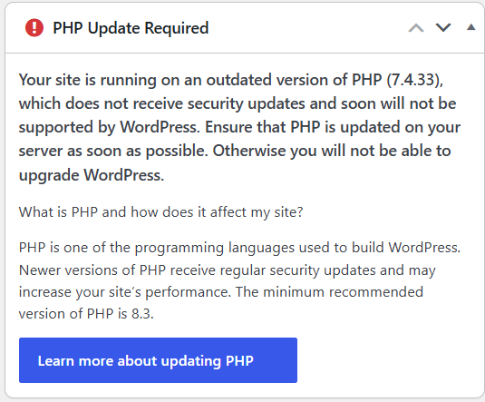
Many Plugins need to be updated along with the php version so that websites can be saved from potential hacks.

The Atipriye Soch Foundation Bible
Sep 25, 2026 · @Dr. Ati Priye

Who we are
Atipriye Soch Foundation is a not-for-profit Section 8 company in Ludhiana, Punjab, incorporated on 27 March 2024. Since 29 June 2026 its registered objects formally cover four pillars: child education, women empowerment, men's mental health, and transgender equality.
Item | Detail
Legal form | Section 8 company, limited by shares (Table A)
CIN | U85500PB2024NPL061137
NGO Darpan ID | PB/2024/0407003
Incorporated | 27 March 2024
Registered office | #2780, St. No. 5B, Guru Nanak Colony, W. No. 61 Block-B, GNE College, Ludhiana 141006, Punjab
Authorised capital | Rs 15,00,000 (1,50,000 equity shares of Rs 10)
Industry classification | Educational support services (unchanged by the 2026 alteration)
Area of operation | Whole of India (MOA text also says all countries of the world)
Founder and signing director | Dr. Ati Priye
Co-director | Rekha Priya

The four pillars
Every programme we run must trace back to a numbered main object in the MOA. This table is the map.
Pillar | MOA main objects | What it lets us do
Child education | 1, 2, 6, 7 | Run schools (including pre-schools), vocational centres, hostels; curriculum R&D; student and staff health and welfare
Women empowerment | 2, 3 | Skills and livelihood programmes for women; homes and hostels for women and orphans; gender-equality work
Men's mental health | 8 (added 2026) | Counselling, peer support, helplines, crisis intervention, rehabilitation, volunteer and first-aider training, research and advocacy focused on men and boys
Transgender equality | 9 (added 2026) | Education, livelihood, shelter (Garima Greh), legal aid, documentation, healthcare access; act as implementing agency for the SMILE scheme
Objects 4 (animal and nature welfare) and 5 (disaster relief) also remain live. They are not pillars today, but they let us respond to calamities or run environment programmes without another MOA change.

Main objects in plain language
The MOA now has nine main objects under clause 3(a); 1 to 7 date from incorporation and 8 and 9 were added by special resolution of 30 April 2026.
No. | Theme | What it permits, in short
1 | Educational institutions | Set up and run schools, colleges, vocational centres; partner with government and NGOs; education research and curriculum development
2 | Inclusive education and skills | Special education and job skills for children, women, elderly and differently abled; livelihood projects
3 | Livelihoods and equality | Housing, food, clothing, health and education for disadvantaged people; women's empowerment; homes for women, orphans, elderly; day care
4 | Animals and environment | Animal welfare, endangered species, biodiversity awareness and research
5 | Disaster relief | Relief for people and animals in floods, fire, epidemics and similar calamities; contributions to relief bodies
6 | Welfare of school communities | Charitable trusts, medical facilities and health check-ups for students, teachers and staff
7 | Residential and co-curricular | Hostels for students from remote areas; cultural, artistic and sports activities
8 | Mental health and men's wellbeing | Awareness, counselling, peer support, crisis intervention, helplines, rehabilitation; training volunteers and mental-health first-aiders; work with NIMHANS and State Mental Health Authorities under the Mental Healthcare Act 2017; research on men's mental health and suicide prevention
9 | Transgender equality and inclusion | Rights and dignity of transgender, intersex and gender non-conforming persons; education, livelihood, shelter, legal aid, documents, healthcare; SMILE scheme implementation; Garima Greh homes; advocacy under the Transgender Persons (Protection of Rights) Act 2019

